Melbourne University Law Students’ Society Inc

Melbourne Law School
185 Pelham St
Carlton VIC 3053
Australia
ABN 81 497 247 589
+61 3 8344 6179
lss-info@unimelb.edu.au
www.mulss.com

Melbourne University
Law Students’ Society

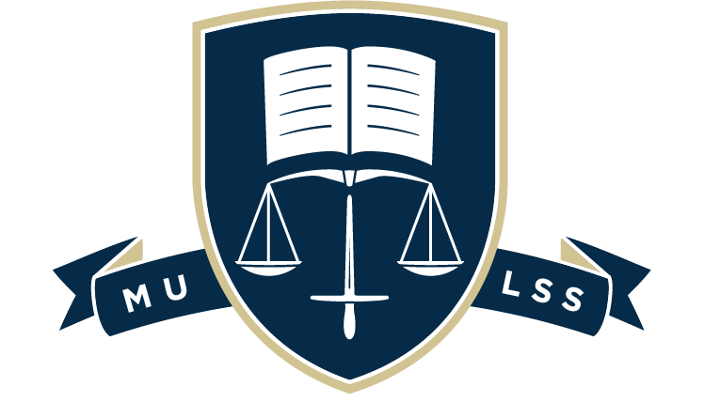

Sexual Misconduct Policy
As at 11 April 2022

I Purpose
- The Melbourne University Law Students’ Society (MULSS) acknowledges that sexual misconduct can occur in any setting, at any time, to anyone. The MULSS is committed to ensuring that our events, initiatives, and online platforms are a safe and respectful space for all persons. To that end, the members of the MULSS individually and collectively must adhere to this policy. The objective of this policy is to:

  - Outline the disclosure process;

  - Commit MULSS to listening to victim-survivors, believing victim-survivors, and helping victim-survivors;

  - Set out preventative action;

  - Contribute to the broader cultural shift away from sexual violence.
II Scope
A General

- This policy applies to all MULSS members, as defined in the MULSS Constitution, who are victim-survivors or perpetrators of sexual misconduct.

B Definitions

- For the purposes of this policy, sexual misconduct is broadly defined as and non-exhaustively includes:
  - Sexual assault as defined in Crimes Act 1958 (Vic);

  - Sexual harassment as defined in the Sex Discrimination Act 1984 (Cth);

  - Other instances of sexual misconduct not canvassed in the above definitions.
III POLICY
A Making a disclosure
- A MULSS member may make a disclosure about a current or past event of sexual misconduct, whether it concerns themselves or others.

- A MULSS member may make a disclosure to any member of Committee.

  - In the case of the MULSS member contacting a member of Committee who is not on the Leadership Team:

    - The MULSS Committee member who receives the disclosure will communicate it to the Leadership Team.

    - The disclosure can be communicated anonymously to the Leadership Team, at the discretion of the MULSS member making the disclosure.

- Disclosures will be recorded in the MULSS Internal Incident Report Register.

  - The MULSS Internal Incident Report Register is only accessible to the President and Secretary of the MULSS.

  - The information recorded in the MULSS Internal Incident Report Register is intended to centralise documentation and guide preventative and reactive action.

  - Incident Reports can be requested by the victim-survivor.
B Managing a disclosure
- The MULSS will take all reasonable steps to support the MULSS member making the disclosure, recognising that the first disclosure is an important and difficult step, and how it is received may influence the victim-survivor’s decision to proceed with formal action.

- The MULSS will not conduct investigations, as the MULSS consists only of student volunteers and there are alternative avenues better equipped to successfully and sensitively handle these matters.

- The MULSS may facilitate the following:

  - Access to internal and external counselling and advisory services. This includes:

    - Safer Community Program;

    - University of Melbourne Counselling and Psychological Services;

    - Sexual Assault Crisis Line;

    - Victorian Centres Against Sexual Assault;

    - 1800RESPECT;

    - Beyond Blue;

    - Lifeline.

  - Access to internal and external reporting services. This includes:

    - Safer Community Program Anonymous Register;

    - University of Melbourne Complaints and Grievances;

    - Sexual Offences and Child-abuse Investigations Team;

    - Police.

  - Advocacy for alternative or additional academic support from MLS.

- Disclosures, and any documentation generated in the making of a disclosure, will be kept confidential to the extent possible. Reasonable efforts will be made to ensure the confidentiality of persons involved.
C Action following a disclosure
- If the perpetrator of the misconduct is a MULSS member, and any of the reporting services outlined in 5.3.2 are utilised by the victim-survivor, MULSS may take preventative actions pending the outcome of the report and investigation.

  - Preventative actions may include:

    - Issuing a formal letter providing notice to the perpetrator that MULSS is aware of an incident of sexual misconduct;

    - Denying access to specific MULSS events or all MULSS events;

    - Denying or terminating MULSS membership;

    - Limiting or ceasing duties if the perpetrator is a member of the MULSS Committee, as defined in the MULSS Constitution.
D Reports to police
- Many forms of sexual misconduct constitute criminal conduct.
- If the MULSS member wishes to make a report to police, they should report to the relevant authority in which the incident occurred. The MULSS will assist in identifying the relevant authority.
- The MULSS will respect and prioritise the wishes of the MULSS member making the disclosure but retains the right to report an incident to the police if it concludes that doing so would be in the best interest of the safety and wellbeing of the wider University community.
E Prevention
- The MULSS will continue to ensure Committee members undertake Active Bystander Training, recognising that passivity helps uphold the system of sexual violence.

- The MULSS will have designated Welfare Officers at all events involving alcohol, recognising that social events where alcohol is supplied tend to be a higher risk environment than other MULSS events.

- The MULSS will work collaboratively with the Safer Community Program to ensure that preventative measures are up to date and reflect best practices.

