BAKER MCKENZIE STATE PARTY NEGOTIATIONS 2023
PRESENTED BY MULSS INTERNAL COMPETITIONS
SPONSORED BY BAKER MCKENZIE

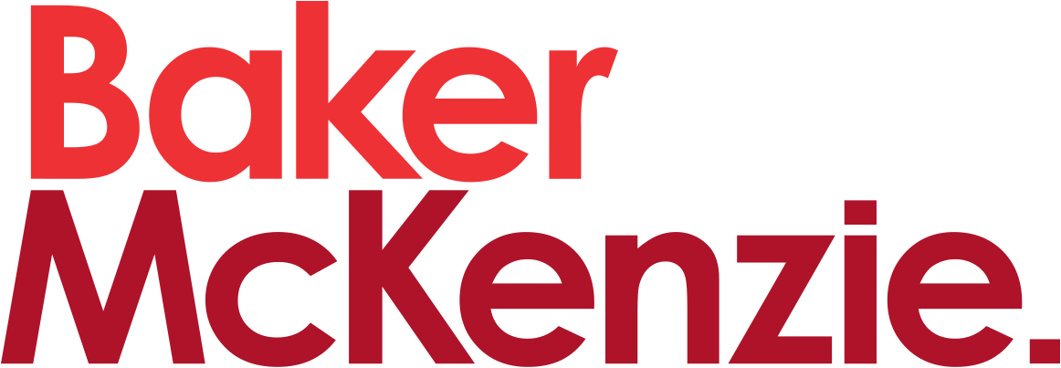

THE COMPETITION GUIDEBOOK

TABLE OF CONTENTS

WELCOME 2
OUTLINE OF THE COMPETITION 3
STRUCTURE 4
RULES 5
JUDGING 6
THE PROBLEM 7
ORGANISING TEAMS 7
SCORING 7
FURTHER RESOURCES 8

WELCOME

The MULSS Internal Competitions Portfolio is proud to present the sixth iteration of the State Party Negotiation competitions. This Competition was created in 2018 to provide students with an opportunity to learn more about aspects of public international law that are outside the scope of the International Humanitarian Law Moot. The Competition is designed to give participants a greater insight into how states negotiate with one another in a multilateral setting. This Guidebook contains a brief overview of the rules and the structure of the State Party Negotiation Competition in 2023.
This year’s State Party Negotiation will give teams of two the opportunity to represent one of the five permanent members of the United Nations Security Council (China, France, Russia, the United Kingdom, the United States) as they attempt to develop a solution to an ongoing international crisis. Teams will work together to draft a resolution to be presented at a formal session of the entire Security Council. Each team will be assessed on its ability to shape the text of the draft resolution to reflect the interests of the state that it is representing.
State Party Negotiation is a great entry-level competition because no prior legal knowledge is expected or required in order to participate. It also gives participants a great opportunity to develop their negotiation skills. However, the Competition differs from traditional Negotiation in the sense that teams must now account for an array of diverse perspectives rather than the interests of a single opponent. This added complexity makes State Party Negotiation a sometimes challenging but also deeply rewarding experience.
We thank you for your interest in State Party Negotiation and we look forward to your participation!

Bronte Smith and Mardi Sutherland
Internal Competition Directors 2023
competitions@mulss.com

Georgina Warren and Angelique Del Monaco
State Party Negotiation Officers 2023
statepartynegotiation@mulss.com

OUTLINE OF THE COMPETITION

The State Party Negotiation Competition is, at its core, a negotiation competition, but participants will also be able to practice drafting written memoranda as well as resolutions, declarations or decisions once a general consensus has been reached by all the parties involved.

Each team of two students will be randomly assigned a state and will be responsible for reaching agreements with other member nations to draft a resolution or amendments that would favour their assigned state. The objective of your delegation is to reach consensus with other delegates.

Prior to the negotiation, teams will be given (i) the problem question; and (ii) the draft resolution. Teams will then be required to draft written memoranda, outlining their state’s response to the draft resolution.

During the conference, teams will be expected to address the agenda in light of their state’s interests. The aim is to build consensus with other member states so that a resolution or decision that is favourable to your state is adopted. In addition, your team will work with other member parties to achieve an outcome that balances both their interests as well as that of your state.

At each conference, there will be a total of five teams (one for each permanent member of the Security Council), a Chairperson (judge) to facilitate the negotiation process and a Deputy Chairperson to track amendments to the draft resolution.

STRUCTURE

- The Competition consists of three rounds. The first two rounds will be a preliminary round. The third round will be the Final Round.

- Only the top five teams will advance to the Final Round. This will be determined by each team’s score after the first two rounds.

- The problem will be released three (3) days before the conference is due to take place. Teams will be assigned a state at random.

- The problem will include the factual scenario and text of a draft resolution with three clauses that will be the subject of negotiation. Each team will have to address them in their written memoranda as well as on the day of the conference.

- Teams will need to draft a written memorandum. This will be no longer than one (1) page (single-sided). The completed written memoranda must be emailed to <statepartynegotiation@mulss.com> 24 hours prior to your team’s assigned conference. Penalties apply for late submissions (see Rules section).

- Access to the memoranda of the other teams in your round will be released 30 minutes before the start of the round.

- One person from each team will deliver a brief (2 minutes maximum) introduction outlining their state’s position on each of the clauses contained within the draft resolution and their objectives for the negotiation as a whole.

- Once all teams have delivered their introduction, the Chairperson will invite member states to begin discussions. The way this will be indicated will be explained closer to the date of the first round. In the event that no states volunteer, the Chairperson will nominate a state to begin discussions. The negotiation will follow the structure outlined in the Agenda.

- The Competition is expected to run for a maximum of two hours and fifteen minutes, including an intermission of five minutes.

RULES

- Addressing Other Teams and the Chairperson During the Competition
  - Each team is to refer to themselves and the other teams using the names of their assigned states during the Competition.
  - Each team is to address the Chairperson as ‘Honourable Chairperson’.

- Forfeitures
  - In the event that a team is unable to participate in a given round, they must, save in exceptional circumstances, inform the Competition Directors or relevant Co-Opt at least three (3) days prior to the day of their conference or negotiation.

- Interjections
  - Teams may interject to contribute to a discussion or negotiation.
  - Teams may only interject by raising their nation’s flags. The Chairperson will acknowledge and decide the order in which teams are given the opportunity to contribute. It will be on a ‘first in, best dressed’ basis.
  - Teams are permitted to interject as many times as is considered reasonable and practicable during the conference. This will be moderated by the Chairperson.
  - There is not a strict time limit with respect to each team’s interjection. However, it is recommended that interjections do not exceed two minutes or longer than necessary. The duration of interjections will be moderated by the Chairperson.

- Nation’s Address
  - Each team will begin with an introductory address delivered by one member of the team. The address will outline their state’s attitude to the clauses contained in the draft resolution.

- Written Memorandum
  - Teams must submit their written memorandum 24 hours prior to their day of competition.
  - The written memorandum will consist of an outline of a given state’s attitude towards the clauses of the draft resolution and their objectives for the negotiation.
  - All written memoranda must be emailed to statepartynegotiation@mulss.com.
  - Written memoranda will make up 5 out of a total of 50 points for the Competition.
  - Late submissions of written memoranda will attract a penalty of 2 points for the first half-hour and 1 penalty point for every half hour thereafter. The number of points lost for late submissions is capped at 5 points.

JUDGING

- The Chairperson and Deputy Chairperson of the conference will co-judge the Competition in each round.

- The decision of the Chairperson at a conference is final and cannot, under any circumstances, be appealed.

- An exception to the finality of a judge’s decision is if the decision is regarding the point penalties as outlined in paragraph 5(v) of the Rules. In order to give effect to Rule 5(v), a judge can, where necessary and appropriate, amend the final score(s) of team(s) which do not abide by Rule 5(v).

THE PROBLEM

- The problem will be focused around a particular country. Competitors will be given a fact sheet detailing the history of the chosen country and the surrounding circumstances that have created the current geopolitical situation/conflict/issues. Competitors will also be given a draft resolution for which the state parties will negotiate the wording in a bid to pass the resolution.

- The entire Competition is based around issues in the three clauses in the draft resolution. The fact sheet and the resolution will remain the same through the entire competition with teams changing which state party they will represent throughout the rounds.

ORGANISING TEAMS

- The Competition will be open to the first 25 teams that sign up.

- Teams will be allocated into pools for the preliminary rounds of the competition.

SCORING

- The total number of points for the Competition is 50.

- The written memorandum is worth 5 points.

- The remaining 45 points will be allocated for:

  - Ability to work collaboratively with other states to reach a general consensus;
  - Clarity of communication – persuasiveness, style, structure;
  - Time management;
  - Approach to addressing the key issues;
  - Teamwork – presenting a united front, equal participation;
  - Recognising the strengths and weaknesses of other member states;
  - Research of relevant facts, policies;
  - Diplomacy – ability to establish a constructive working relationship and alliances with other nations; and
  - Ability to draft an appropriate resolution in accordance with the general consensus.

FURTHER RESOURCES

MULSS Internal Competitions Code of Conduct 2023:
- https://docs.google.com/document/d/1c6VWxjyi9xeCzq4ArL4k99IXyW_G8kGbcqqxT1r4YLo/edit?usp=sharing

Escalation Pathway & Penalty System 2023:
- https://docs.google.com/document/d/1VquH8h8xkA0i8Xihn-UdCNSJqY3HzFdf2lyeft-AkqI/edit?usp=sharing

